# **Historical Data Excel Workbook**

## **Introduction**

The Historical Data Excel spreadsheet helps with historical data purchased from Betfair by offering a means for download, display and analysis.

The prerequisites for using the Historical Data Excel Workbook are:

* You must have previously purchased data via <https://historicdata.betfair.com> using your Betfair account.
* Install **7-Zip** before using the spreadsheet, which relies on 7-Zip to manage the compressed data.

### **Please note:**

Use of the Historical Data Excel Workbook is recommended for use with the BASIC historical data files only. Use of ADVANCED or PRO files will significantly reduce performance.

Source code is accessible within the spreadsheet, which is user-configurable and expandable.

The local database created by the spreadsheet is maintained in a compressed state to save space. Decompression of relevant data is carried out ‘on the fly’ as required.

## **Control sheet overview**

This contains the fields and buttons required for login to Betfair, and for defining the location of Z-Zip and the local Historical data.

To login click the  and then enter your Betfair username and password into the Login window before pressing Login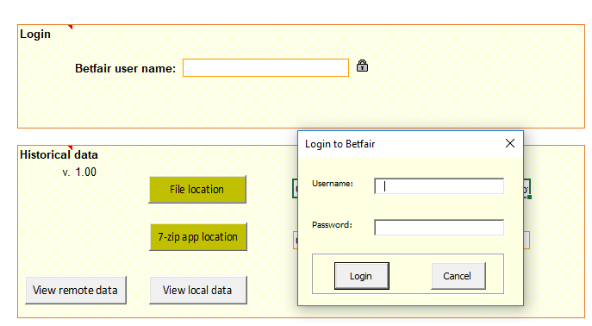**Please note:**  that login to Betfair is required to access the remote data. The workbook stores and re-uses the Betfair session token, which means login is only occasionally necessary once a session expires.

## **File location & 7-zip location buttons**

Initially, the ‘7-zip app location’ button can be used in conjunction with the associated ‘path’ field to configure the location of the 7-zip software.

The ‘File location’ defaults to a “**\Data”** subdirectory for the location of the downloaded data. Other locations can also be used by modifying this field, if required. By clicking on the ‘File location’ button and selecting the directory into which you’d like the data to be stored.

## **View remote data & View local data buttons**

Once configured, the most commonly used buttons are the grey ‘View remote data’ and ‘View local data’ buttons.

**‘View remote data’** - allows purchased data to be browsed and selected portions to be downloaded to the local database.

**‘View local data’** - browses the local database and facilitates inspection and reporting to new sheets within the workbook.

An additional, temporary button: ‘Shrink windows’ appears when display windows appear. Clicking this toggles all such windows between a reduced title and normal state; which is occasionally useful for managing them.

## **‘Remote Historical Data purchases’ window**

The**‘View remote data’** button brings up a window displaying a list of the blocks of data currently purchased from <https://historicdata.betfair.com>

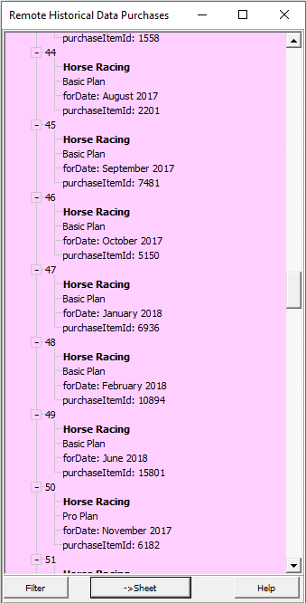

Click on a listed item to proceed with download.

Prior to the actual download process, a dialog allowing data selection is presented: the ‘**Filter Remote Purchase’ dialog.**

## **‘Filter Remote Purchase’ dialog**

The Filter Remote Purchase dialog displays data from currently highlighted block in the ‘Remote Historical Data Purchases’ window and allows amendment and refinement to specify what to download.

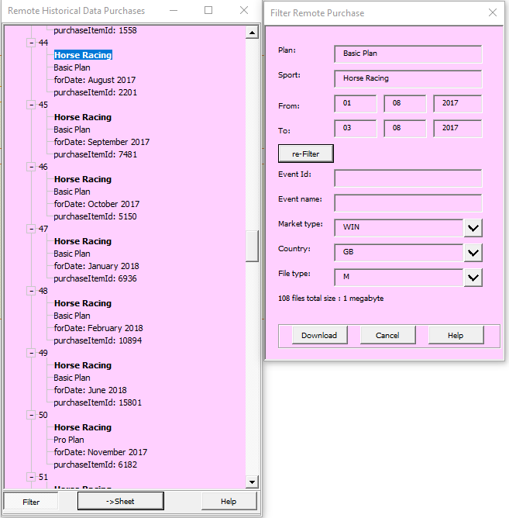

**Note:** After amending the existing selection parameters (i.e. Date range, Sport, or Data Level) a temporary ‘re-Filter’ button will appear to allow the possible choices for the other selection fields to be updated appropriately.

## **‘Download progress’ window**

After clicking ‘Download’ on the ‘Filter Remote Purchase’ dialog, the ‘Download progress’ window appears and download commences.

The chosen list of market files is displayed. Progress is indicated by the vertical side bar. Speed is dependent on the number of concurrent downloads allowed (specified on the ‘Hidden Control’ sheet).

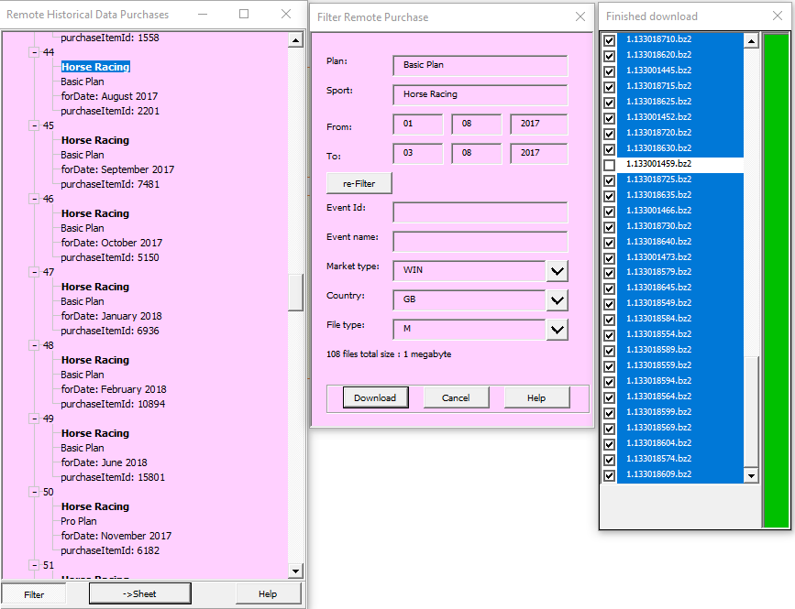

**The resulting files are then incorporated into the ‘Local’ window and can be browsed from there using the “View local data button”**

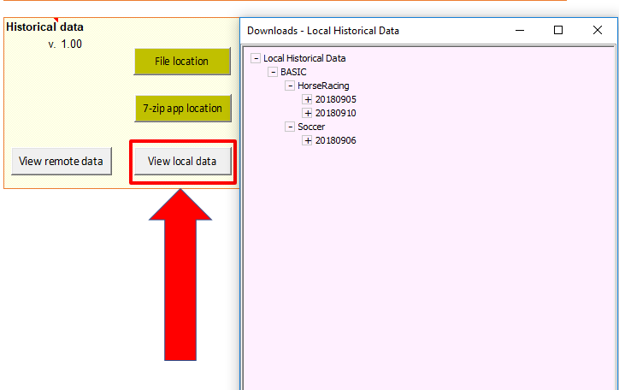

## ‘**Downloads – Local Historical Data’ Window**

After expanding the tree, individual market data is loaded by clicking a leaf node. The “**Graphic report 1”** is displayed by default.

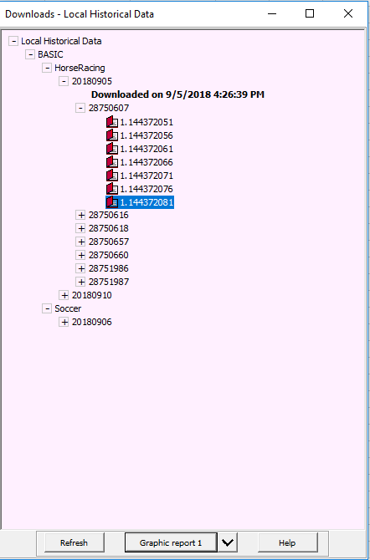

## **Features of Graphic report**

* Provides summary of market selections and event
* Allows interactive selection of displayed Runners on graph, by selecting Sparkline column cells (e.g. ctrl-click, shift-click).
* Highlights winner names in bold/italic. **Please note:**  .tar files downloaded directly from the website can be incorporated. Just move them to the Historical data workbook’s data folder and name them appropriately. They will then become incorporated into the ‘Local’ window

**Graphic Report 1 (Example)**

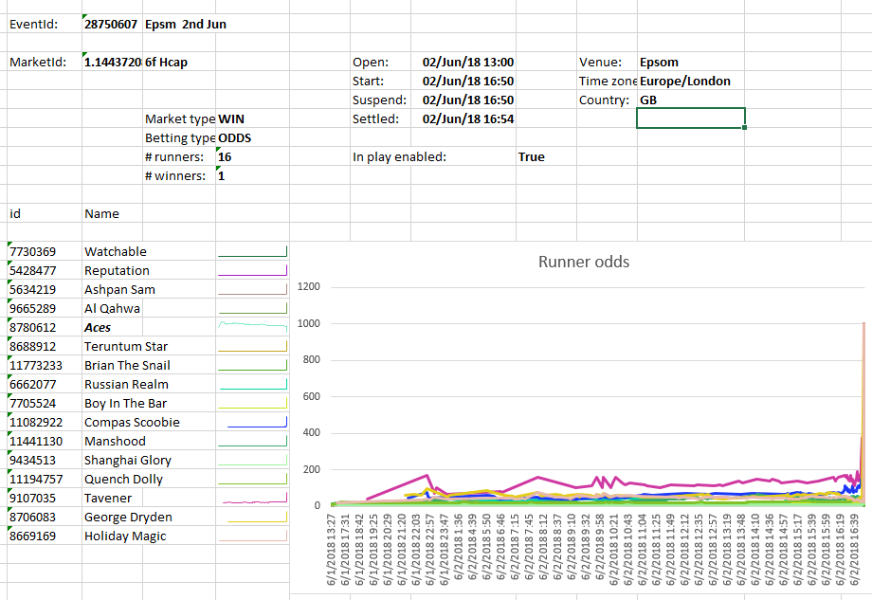

## **Other reports**

Other reports can be selected from the reporting dropdown menu once a market has been selected.

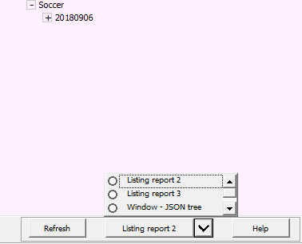

## **Listing report 1**

Provides a simple report, organising the data into the following columns:

* Time – the time and date of the update
* MarketId – the marketId
* Status - the status of the market
* In-Play – whether the market as in play or not
* SelectionId – the Id of the selection
* LastPriceTraded – the last price traded on the selection

## **Listing report 2**

Provides the raw JSON data organised into separate columns. These fields are documented in the [historical data specification](https://historicdata.betfair.com/Betfair-Historical-Data-Feed-Specification.pdf)

## **Windows – JSON tree**

Allow you to browse each individual JSON message with a tree node structure.

# **‘Hidden Control’ sheet**

‘Hidden Control’ sheet has some less-used options.

## Session key

The latest Session key from Betfair is stored here and used until re-login is required at which point it is updated.

## **Help locations**

Help button triggered on the windows connect to the addresses specified on this page. Note that the Help buttons load their pages asynchronously so if the page is unavailable, nothing will happen, rather than hanging the workbook application.

## **Use speech**

A setting of ‘TRUE’ causes the application to speak messages aloud. Uses the Excel text-to-speech facility.

## **http utility object**

Specifies the name of the software component used to connect to the web.

## **Concurrent downloads**

Many files can be downloaded simultaneously. The number to simultaneously download is specified by this ‘Concurrent downloads’ number. The optimum number may be dependent on individual

Feature: Type ‘TRUE’ into ‘Use speech’ for user messages to be read aloud via the Excel text to speech facility.

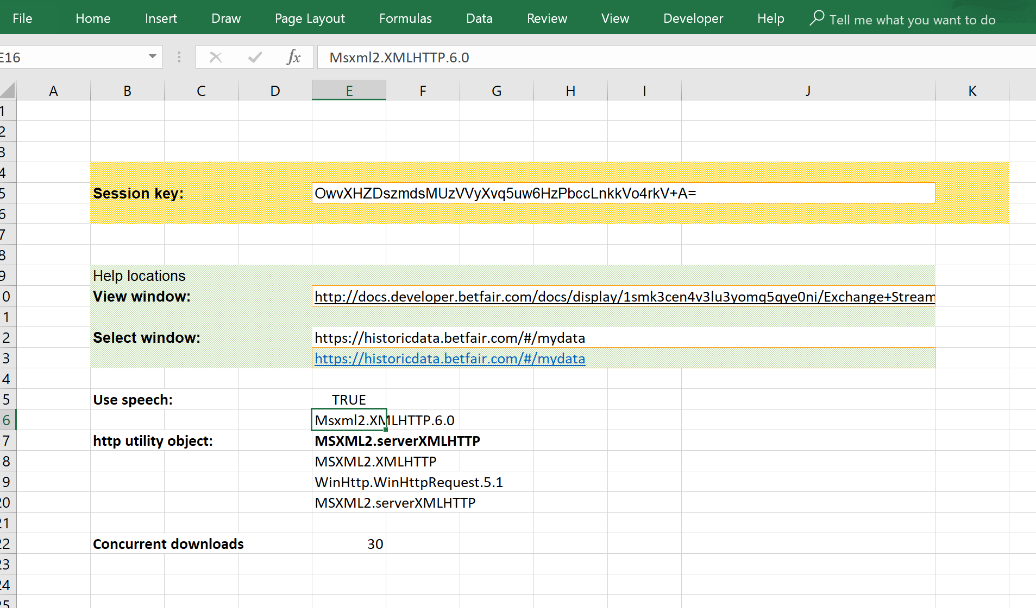

## **Common tasks**

### Revealing the Hidden Control window

To reveal hidden windows within Excel, right-click any sheet tab and select ‘Unhide’ from the pop-up menu.

Select ‘HiddenControl’ to reveal the Hidden Control sheet to be able to view/change the options there.

Select ‘mkt__1’ to reveal the template for the Graphical Report 2. Changes to this template will alter the output from that report.

## **Acknowledgements**

### 7zip

1. HistoricalData.xlsm uses parts of the 7-Zip program
2. 7-Zip is licensed under the GNU LGPL license and
3. 7-Zip source code can be found at [www.7-zip.org](http://www.7-zip.org)

## clsTreeView

HistoricalData.xlsm currently uses the free version of clsTreeView

Company : JKP Application Development Services (c)

Author : Jan Karel Pieterse (www.jkp-ads.com)

Created : 15-01-2013

Purpose : Creates a VBA Treeview control in a frame on your UserForm

Contacts: info@jkp-ads.com, http://www.jkp-ads.com

Peter Thornton, pmbthornton@gmail.com